|  |  |
| --- | --- |
| Icon  Description automatically generated  FARMTRUST  White Paper | GTRST TOKEN  *Cares More About Farmers*  Dong Zheng  FT5008 Research Project |

# Introduction

Agriculture is a crucial component of the economy in Southeast Asia. Southeast Asia is a large exporter of agricultural products, particularly crops, fish, and seafood. However, most agricultural companies, especially smaller farmers, appear to be as risky as it has been due to the dual challenges of unstable market conditions and changing weather patterns. Prices for agricultural products tend to fluctuate significantly, causing a high level of uncertainty among producers and consumers. It is essential to implement price stability and strengthen the idea of risk management for adverse climate incidents.

Farmtrust utilizes tokenization by converting rights to assets into digital tokens on the blockchain, designing **GTRST** for providing futures and insurance services. Farmtrust provides futures services that lock the purchase price of agricultural products in advance, and climate crop insurance offers small farmers an opportunity to mitigate climatic risks. Due to geographic fragmentation and unjustifiable data, the traditional type of indemnity can be time-consuming and costly.

# Problem

## Futures Industry

Boom and bust events tend to characterize agricultural markets. High price and income volatility levels for farmers are related to market fundamentals of supply and demand. The nature of food as a primary social necessity leads to price inelasticity. Farmers tend to plant current hot-selling or previously popular varieties. Still, the supply often cannot respond quickly to price changes since it usually takes significant time to produce agricultural products. The limited price responsiveness of demand and supply damage market equilibrium in various ways. These endogenous risks are the result of the behavior of market participants.

Futures, in this case, can serve as a risk management tool that allows farmers to "lock in" a specific harvest price for their agricultural production, preventing the possibility that their selling price will fall in the future. The risk is now transferred from the farmers to speculators, who are willing to accept the risk in the hopes of profiting from a "hedging" method. Futures can also be an instrument for price discovery by reflecting the price expectations of both suppliers and consumers, which allows farmers to estimate future spot prices for their products.

## Insurance Industry

Farmers are also exposed to exogenous risk, independent from market conditions and caused by weather and climatic factors. Frequent heat waves, erratic rainfall, flooding, and other extreme weather events caused by climate change devastate the agricultural industry. Farmers worldwide are exposed to significant agriculture risks due to the vagaries of nature. Although crop insurance has been implemented in many countries for years, it has been beset with several problems, such as lack of transparency, high premium, and non-payment/delayed payment of claims to farmers. This traditional scheme can be prolonged and tedious. Given its complexity, farmers without prior exposure to such procedures might have difficulty understanding how this insurance works. Such misunderstanding will lower the acceptance rate of the product.

Furthermore, agricultural insurance can be costly and exorbitant to providers and farmers. Firstly, the insurance company must have sufficient reserves to meet the farmers' claims because the reserve capital threshold will be high when a severe adverse weather incident happens. Additionally, concrete evidence will need to be provided to the insurance company to obtain compensation. The process of checking the validity of the evidence can be slow and costly in terms of human labor.

# Solution

Farmtrust provides two products to tackle the above mentioned problems: Farmtrust insurance and Farmtrust futures service. Both are based on smart contracts to ensure data integrity/transparency and ease of access for local farmers in SEA.

## Farmtrust Insurance Product

Our insurance solution consists of two operation cycles and four major parts. The overall structure and components of the insurance process for farmers and investors are introduced below: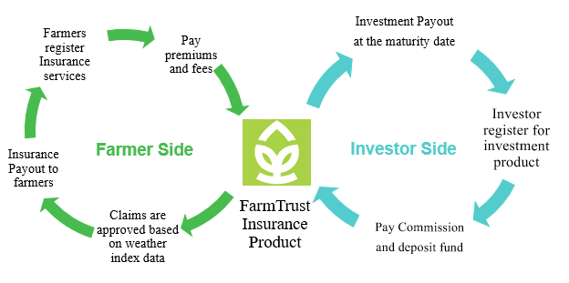

**Farmtrust** is a peer-to-peer insurance platform that provides insurance products and processes claim and payout transactions in GTRST-L tokens. The platform also ensures that the smart insurance contracts are appropriately designed and that GTRST-P tokens are awarded correctly after each successful transaction.

**Farmers** can register and upload their personal and farm information, such as geographical location, through Farmtrust's platform. Farmtrust will then place weather sensors in farms' fields to collect data for index-based insurance. Afterward, farmers can subscribe to Farmtrust insurance services by paying the GTRST-L token to relevant smart contracts on the Farmtrust platform.

**Investors** must also register at the Farmtrust platform, indicating their risk tolerance and preferences. Then the platform will recommend the optimal investment product based on their settings. Investors need to deposit the fund into the selected smart contract insurance. The smart contract will automatically dispense the profits and GTRST-P tokens to investors at the contract maturity date.

**Weather Index-based smart contract** is the critical component of Farmtrust insurance. It contains crucial information such as farm geological coordinates, number of plants, and payout policies. The smart contracts also have an API connection to the field sensors and weather data. If extreme weather conditions happen, the smart contracts are triggered automatically to pay the farmer's insured amount of the GTRST-L token.

## Farmtrust Futures Service

The second product on the Farmtrust is agriculture futures service. Farmers can use Farmtrust's future contracts to secure prices for their agriculture products. To sell a futures contract on Farmtrust, farmers must first raise a request and use their planting as collateral. Farmtrust will do the due diligence check and evaluate the future contract's value. The brokerage firms can retrieve these future contracts' information through Farmtrust's API and sell them at the exchange or OTC market. After the harvest, farmers will need to submit their agricultural products to the Farmtrust platform. Farmtrust will take care of the storage and physical delivery of farm products. Once fund and product exchanges are settled, money will be automatically transferred to the farmer's account by smart future contract. Moreover, brokerage firms and local farmers will receive the GTRST-P as a reward every time they complete a futures trade to improve their credit rating.

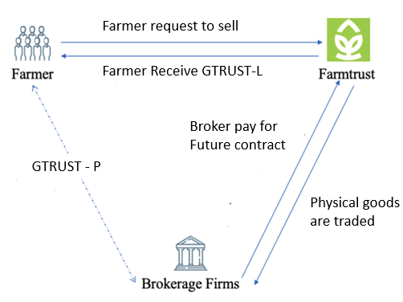

# GTRST Token

GTRST is an Ethereum blockchain technology-based cryptocurrency issued by Farmtrust. It is the core asset in the circulation framework. GTRST can be divided into two types: Type L can be used for trading and is linked to the real-time price of ETH; Type P can be used for credit evaluation and does not have a monetary value.

## GTRST Mechanism

As shown in the figure, in the multi-party framework constructed by Farmtrust, the main body of information and capital exchange is Farmtrust itself. For the inner loop, the farmer is in the form of GTRST-L when purchasing insurance or delegating futures trading. Likewise, investors must convert their funds to GTRST-L when they select the investment categories offered by Farmtrust. This mechanism was initially designed to use GTRST-L as a link to record the complete on-chain behavior using blockchain technology to build a trusted network and capital ecosystem between the three parties. As for the outer loop, financial dealings between Farmtrust and brokerage firms will be in USD to be stable and compatible with the current futures contract system.

It is worth mentioning that Farmtrust borrows the design idea of stablecoin and introduces GTRST-P for credit evaluation of all external entities involved in the GTRST circulation framework. After each transaction is completed, both parties must use the GTRST-P to score each other's trading behavior (some of the GTRST-P will be burned). In a real-world trading scenario, the GTRST-P will be directly linked to, for example, premiums, fees, and yields to incentivize or penalize trading participants.

## GTRST Application Scenario

As an issuer of GTRST-L and GTRST-P tokens, Farmtrust needs to use GTRST-L as a carrier for its payment and GTRST-P for cooperation with farmers and customers. For investors, their mechanisms will determine the tokens' investment and appreciation properties. Although the issued token has transaction properties similar to real currency, it can be used to deal with problems that are difficult to solve in real currency by using its characteristics.

### More convenient financing

Compared to IPOs, companies raising funds through GTRST-L tokens can bypass many qualification checks and do not need to provide actual commitments. Investors are flocking to the potential benefits of tokens. Consequently, they also need to be prepared to bear huge risks. The company can sell tokens to investors at a certain price and issue specific dividends to any token holder efficiently.

### Safer and faster insurance services

At Farmtrust, users can only pay with GTRST-L tokens. The company will review the qualifications of companies or users who can receive tokens to ensure that the payer will not be defrauded. As for traditional insurance companies that charge real money, users may be induced by criminals to transfer money to their accounts and suffer losses. In addition, general transfers need to go through multiple banks and review layers, but using GTRST-L tokens for payment can quickly and anonymously complete transactions and acquire insurance services.

### User benefits for beneficial behavior

User welfare can improve user stickiness and increase the attractiveness of tokens. When farmers perform well, the company records the behavior. If a crop sales contract is completed as promised, or the number of insurance claims is less than that of other farmers. When these good behaviors add up and reach a certain standard, the company will list the user as a good user and provide rewards in tokens. Or if an old user recommends a new user, the company can also give GTRST-P token rewards. Users with tokens can exchange for specific products and services of the company. For example, farmers can exchange tokens for cooling products such as fans during the busy farming season. During the autumn harvest season, farmers can use the tokens to exchange for discounts on electricity bills and rent agricultural machinery such as combine harvesters, farm trailers, etc., provided by the company at a lower price.

### Punish impairing behavior

Everyone is profit-seeking. When some users become greedy, the company needs to have the ability to stop it. For example, when a farmer deliberately destroys crops to obtain insurance money, the company can impose a fine by directly deducting the farmer's tokens and increasing the premium the next time the farmer applies for insurance. This approach is straightforward and saves the company the time and money spent on legal battles with farmers.

# Roadmap

After Farmtrust qualifies for the partnership with the government, ICO will be launched. Since GTRST-P does not have a monetary value, it can be issued infinitely in the future, providing sufficient incentives to users after expanding the user pool. For GTRST-L, as shown in the figure, the proportion of tokens held by the company and the public is always equal, hoping to have enough tokens to incentivize users and gain rapid growth in the initial phase after entering the market. Of the token distribution reserved, 60% is used for the initial purchase budget, 25% for maintaining liquidity, and the remaining 15% for developing the user pool. The most significant percentage of the initial token budget will be reserved for R&D and engineering staff and, to a lesser extent, as an incentive for management. In addition, a portion of the tokens will be used for compliance and regulatory incentives to maintain the legitimacy of the ICO and token registration.

Farmtrust plans to enter a few countries where commercial agricultural insurance is unavailable and use the partnership with the government to gain credit backing, thereby gaining farmers' trust and capturing these new markets. After successfully developing and proving the company's business logic in these new markets, Farmtrust will achieve a particular scale and a proven business model. The next step is to expand to other countries where commercial agricultural insurance is already in place and compete with other traditional companies through experiences accumulated in existing markets and the credit backing of governments. The comprehensiveness of the services Farmtrust can offer will be one of the main competitive advantages.

# Limitations and Risk

### Information authenticity

There remains a need to ensure that each participant in the blockchain network, especially individual farmers, provides true and accurate information to the blockchain ledger. The good functioning of the blockchain economy, and especially the good efficacy of insurance products, relies on the quality and accuracy of information. To verify the authenticity and accuracy of the information, Farmtrust needs to invest in sufficient regulatory power. Because macro-environmental factors highly influence agriculture, the company should rely on some third-party data for relative evaluation.

### Internet infrastructure and blockchain education

Internet utilization in rural agricultural areas of Southeast Asia is low, and farmers are not well informed about blockchain. Suppose blockchain-related business needs to be carried out. In that case, it is first necessary to cooperate with local governments to erect decentralized systems in areas with insufficient Internet centrally and have government-authorized organizations manage accounts instead of individual farmers. Farmtrust can also work with the government to implement blockchain education for farmers and promote the benefits of our insurance model by implementing an experience program.